TNT Data:
(3 pts) | 2,4,6-trinitrotoluene (TNT)
Mass of TNT (g) | 1.0197
Initial Temperature (°C) | 25.008
Final Temperature (°C) | 26.476

*you must record accurate data, no rounding or dropping digits, the temperature has five sig figs and mass if below 1 will have 4 sig figs and if above 1 it will have 5 sig figs. I will take points off for carelessness.*

Calculations: (you must show all calculations, it does not matter how simple it is).

1. Calculate ∆T: (1 pt)

∆T = Final Temperature – Initial Temperature
= 26.476-25.008
= 1.468°C

2. Calculate moles of TNT (MM_{TNT} = 227.13 g/mol): (2 pts)

Moles = mass/MM
= 1.0197/227.13
= 0.0044894994056267 moles

3. Calculate q (heat capacity of calorimeter is 10.310 kJ/°C): (2 pts)

Q= C. ∆T
= 10.310 X 1.468
= 15.13508 kJ

4. Calculate ∆H_{combustion} for TNT (enthalpy of combustion): (2 pts)
∆H= Q/ moles
= 15.13508/0.0044894994056267
= 3371.2672924702844 kJ/mol

5. % error: (True value = 3406 kJ) % error = $\frac{True-Exp}{True}$x 100 (2 pts)
(3406 - 3371.2672924702844)/ 3406 X 100
= 1.01975%

[image of initial Temperature] (1 pt)
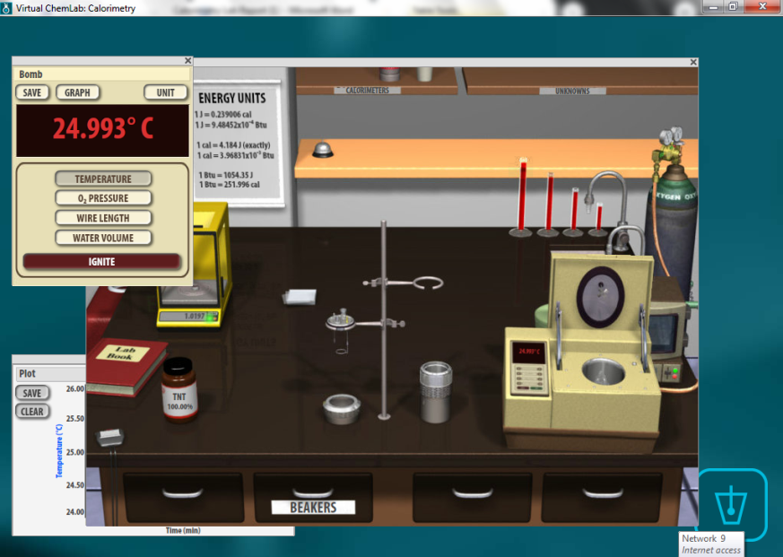

[image of final Temperature] (1 pt)

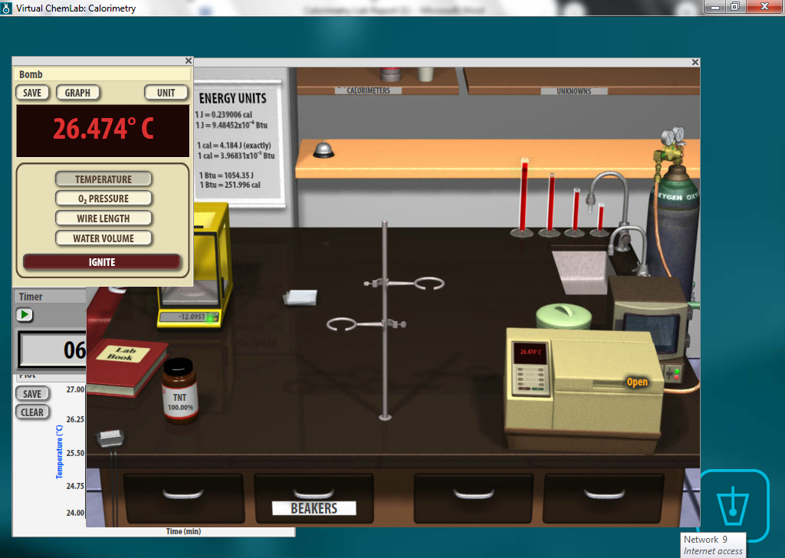

Sucrose Data:
(3 pts) | Sucrose
Mass of sucrose (g) | 1.0683
Initial Temperature (°C) | 25.003
Final Temperature (°C) | 26.704

you must record accurate data, nor rounding or dropping digits, the temperature has five sig figs and mass if below 1 will have 4 sig figs and if above 1 it will have 5 sig figs. I will take points off for carelessness.*

Calculations: ( you must show all calculations, it does not matter how simple it is).

1. Calculate ∆T: (1 pt)

∆T = Final Temperature – Initial Temperature
= 26.704-25.003
= 1.701°C

2. Calculate moles of sucrose (MM_{sucrose} = 342.3 g/mol): (2 pts)

Mole= Mass/ MM
= 1.0683/342.3
= 0.0031209465381244 moles

3. Calculate q (heat capacity of calorimeter is 10.310 kJ/°C): (2 pts)

Q= C. ∆T
= 10.310 X 1.701
= 17.53731 kJ

4. Calculate ∆H_{combustion} for sucrose (enthalpy of combustion): (2 pts)

∆H= Q/ moles
=17.53731/0.0031209465381244
= 5619.2279443977351 kJ/mol

5. % error: (True value = 5639 kJ) % error = $\frac{True-Exp}{True}$x 100 (2 pts)

=(5639- 5619.2279443977351)/ 5639 X 100
=0.35063%

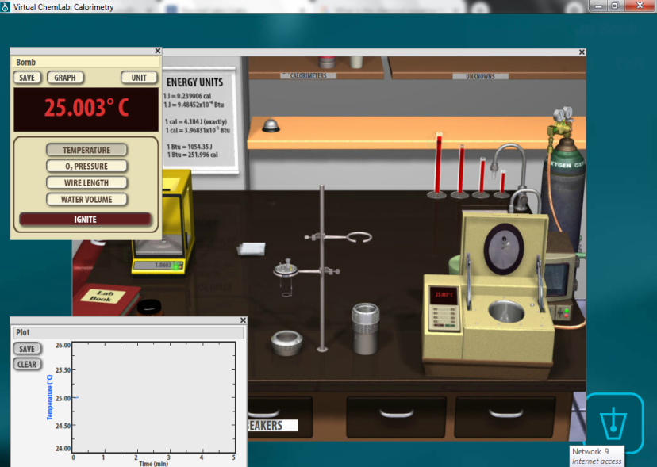
[Image of initial Temperature for sucrose] (1 pt)

[Image of final temperature for sucrose] (1 pt)

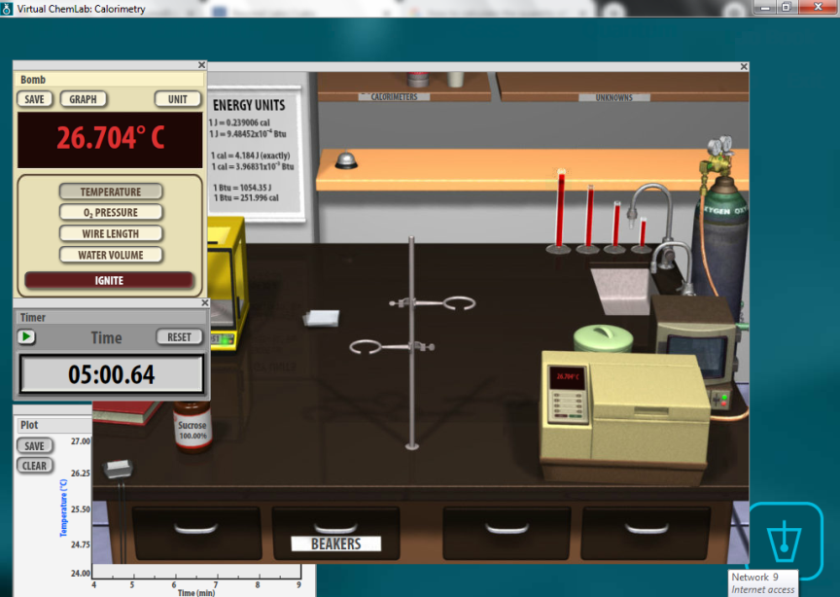

Post-Lab Questions:
1. Write a complete balance equation for combustion of TNT (C₇H₅N₃O₆). (Note along with the other two products for combustion you will also have nitrogen gas for TNT). (3 pts)

4 C₇H₅N₃O₆ + 21 O₂ 28 CO₂ + 10 H₂O + 6 N₂

2. Write a complete balance equation for combustion of sucrose(C₁₂H₂₂O₁₁). (3 pts)

C₁₂H₂₂O₁₁ +12 O₂ 12 CO₂ + 11 H₂O

3. Why do you think the heat of combustion of sucrose is higher than TNT? (2 pts)

The heat of combustion of sucrose is higher than that of the TNT because sucrose is unsaturated and therefore requires a lot of heat energy to burn.

4. Explain what caused the errors in both of your labs. (2 pts)
There are cases of heat losses to the environment and to the calorimeter, hence errors in the data collected.

